**CONFIDENCE INTERVAL FOR DIFFERENCE OF 2 POPULATION MEANS**

1.

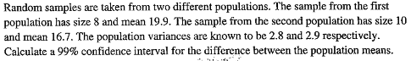

2.

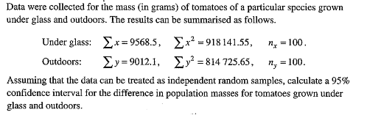

3.

